Read Now: Human Population and Waste Date:__________
As the human population increases, more resources are used.
People buy more food, clothes, and packaged products than before. When these items are thrown away, they become waste.
More people and higher standards of living mean that more waste is produced every day.
This waste needs to be collected, recycled, or disposed of safely.
If waste and chemical materials are not handled properly, they cause pollution.
Pollution can happen in the air from smoke, on land from landfill rubbish, and in water from sewage and fertilizers.
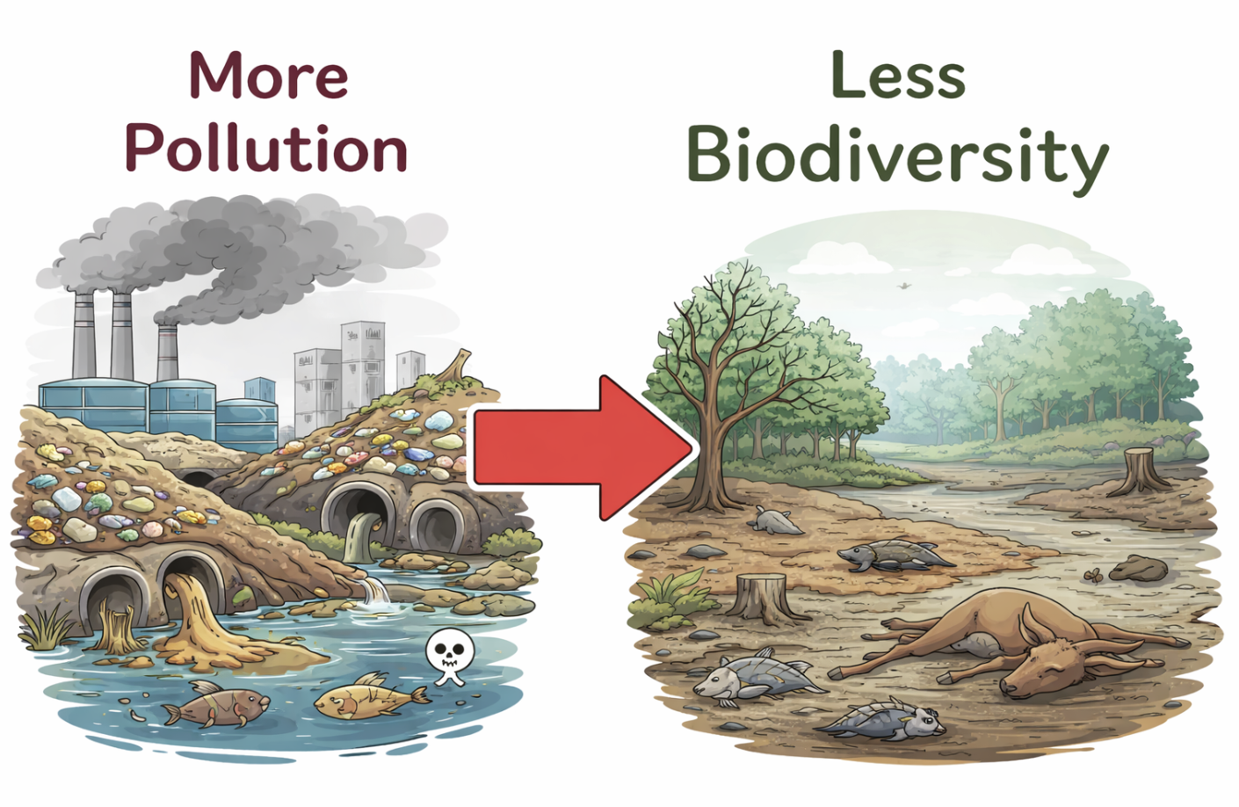
Pollution can harm plants and animals.
Some organisms are killed or forced to leave their habitats. This reduces biodiversity, which means fewer different species live in an area. Biodiversity is the number of different species living in an area.
A polluted environment usually has lower biodiversity than a clean environment.

Questions
- MCQ: What happens to the amount of waste as the human population increases?
A. It decreases
B. It stays the same
C. It increases
D. It disappears

- Complete the sentence:
More people and higher standards of living mean more __________ is produced.

- State one way pollution can be caused by waste.

- Describe what biodiversity means.
Biodiversity means….

- Explain how an increase in human population can lead to a decrease in biodiversity.
An increase in human population leads to more waste, which causes….

1. True/False: All forms of pollution have a negative effect on biodiversity.
2. True/False: Pollution can lead to the loss of biodiversity in ecosystems.
3. Match the words to definitions:
Habitat destruction  Biodiversity  Pollution  Conservation | Efforts to protect and preserve natural resources  The number of different species in an area  Degradation of natural environments  Introduction of harmful substances into the environment
4. Fill-in-the-blank:
_____________ refers to substances that contaminate the environment and can harm living organisms.
The ________ is a measure of the number of different species in an area.

5. State a source of air pollution.
__________________________________________________________________________________________
6. State a source of land pollution.
__________________________________________________________________________________________
7. State three sources of water pollution
_____________________________________________________________________________
____________________________________________________________________________
____________________________________________________________________________

An indicator species shows how __________ an environment is.
If an indicator species disappears, it may mean the environment is __________.

Define an indicator species and explain what it tells scientists about an environment.
________________________________________________________________________________________________________________________________________________________________________________________________________________________________________________________________________

Describe how an increase in the human population affects the amount of waste produced.
As the human population increases,_______________________________________________________ __________________________________________________________________________________________

Explain one way pollution can harm living organisms.
Pollution can harm living organisms by….__________________________________________________ ____________________________________________________________________________________________________________________________________________________________________________________
Explain why pollution can reduce biodiversity.
Pollution reduces biodiversity because _________________________________________________. This means fewer species ______________________________________________________________ ______________________________________________________________________________________

Explain why scientists use indicator species to check pollution levels.
Scientists use indicator species because __________________________________________________ ____________________________________________________________________________________________________________________________________________________________________________________

Read Now: Global Warming Date:_______________
Global warming is the increase in the Earth’s average temperature over time.
Global warming happens because levels of carbon dioxide (CO₂) and methane (CH₄) in the atmosphere are increasing. These gases are called greenhouse gases because they trap heat in the atmosphere.
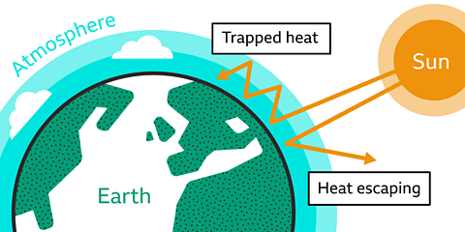
Carbon dioxide levels are rising because humans burn fossil fuels such as coal, oil, and gas for electricity, heating, and transport.
Methane levels are also increasing. Methane is released from farming (especially cows), landfill sites, and fossil fuel extraction.
As more greenhouse gases build up in the atmosphere, more heat is trapped. This causes the Earth’s temperature to rise, leading to global warming.

Questions

- MCQ: What is global warming?
A. The Earth cooling down
B. The increase in the Earth’s average temperature
C. A type of pollution in rivers
D. The movement of tectonic plates

- Complete the sentence:
Global warming happens because greenhouse gases trap __________ in the atmosphere.

- State one human activity that increases carbon dioxide levels.

- Describe one source of methane mentioned in the text.
Methane is released from ____________________________________________.

- Explain how increasing levels of carbon dioxide and methane lead to global warming.
Increasing carbon dioxide and methane levels cause global warming because….

- Imagine greenhouse gases were removed from the atmosphere. What do you think would happen to the Earth’s temperature?
Define global warming.

Define climate change:

Carbon dioxide | Methane
This is released when….  In the atmosphere carbon dioxide is _____________. This is a _____________ ______ which trap __________ in the ________________. | This is released when….  In the atmosphere methane is _____________. This is a _____________ ______ which trap __________ in the ________________.

  - True or False:
Global warming and climate change are the same
Global warming is caused by increased levels of greenhouse gases
Carbon dioxide and methane are greenhouse gases
Deforestation prevents global warming because it means there are fewer trees to emit carbon dioxide
Consequences of global warming include flooding and extreme weather events

  - Label this diagram

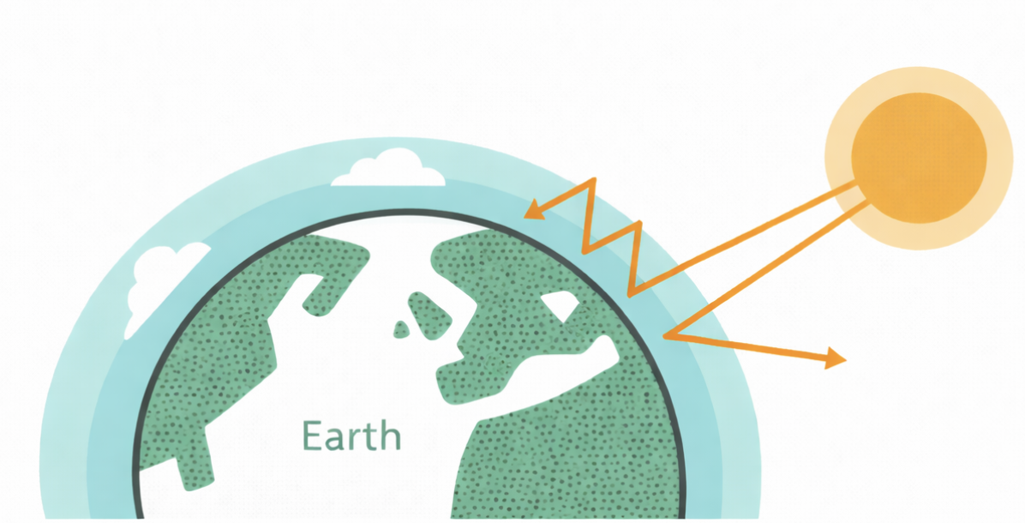

Key labels:

Trapped heat

Sun

Atmosphere

- Draw dots to show where the greenhouse gases would be found

- Name two greenhouse gases.
___________________________________ _____________________________________

- State one cause of carbon dioxide in the atmosphere.
____________________________________________________________________________________

- State one cause of methane in the atmosphere.
____________________________________________________________________________________

- Write 2 sentences describing what is happening in this diagram
____________________________________________________________________________________________________________________________________________________________________________________

  - Describe how global warming can affect plants or animals.
____________________________________________________________________________________________________________________________________________________________________________________

- State two consequences of global warming.
____________________________________________________________________________ ____________________________________________________________________________

- State two biological consequences of global warming that can affect biodiversity of an area.
____________________________________________________________________________________________________________________________________________________________________________________

- Explain how increasing greenhouse gases can lead to a decrease in biodiversity.
________________________________________________________________________________________________________________________________________________________________________________________________________________________________________________________________________________________________________________________________________________________________________
__________________________________________________________________________________________

Read Now: Pyramid of Biomass Date:_________________
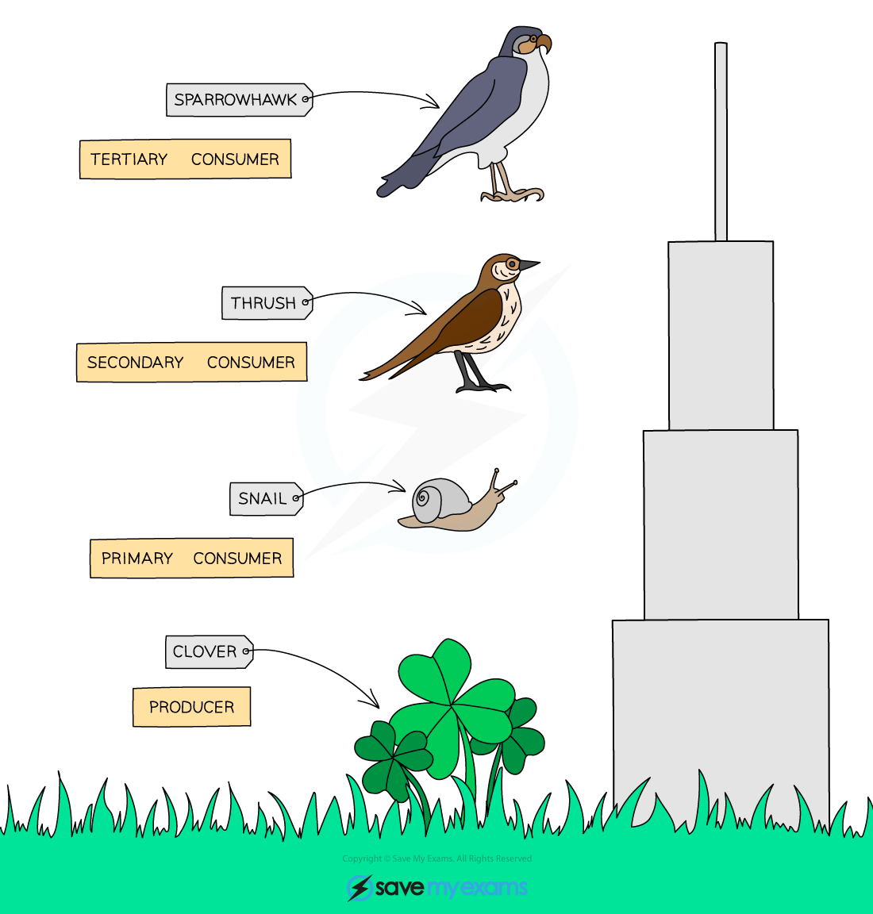
A pyramid of biomass shows the amount of living material at each level of a food chain.
At the bottom of the pyramid are producers, such as plants.
Producers make their own food using photosynthesis and have the largest biomass.
Above the producers are consumers.
Primary consumers eat producers, for example rabbits or insects.
Secondary consumers eat primary consumers.
Tertiary consumers are at the top of the pyramid.
As you go up the pyramid, the amount of biomass decreases.
This is why the pyramid is wide at the bottom and narrow at the top.

Questions
- MCQ: Which organisms are found at the bottom of a pyramid of biomass?
A. Primary consumers
B. Secondary consumers
C. Producers
D. Tertiary consumers

- Complete the sentence:
Producers make their own food using __________________________.

- State one example of a primary consumer.

- Describe where tertiary consumers are found in a pyramid of biomass.
Tertiary consumers are found __________________________.
- State what happens to biomass as you move up the pyramid.
- Imagine a pyramid of biomass where the producers disappear.
What do you think would happen to the consumers above them? Explain your answer.

Read Now: Interpreting Chemical Formulae Date:_________________
A chemical formula shows which elements are in a compound and how many of each element there are.
Elements are shown using symbols, for example:
H = hydrogen O = oxygen C = carbon
A number after a symbol tells you how many atoms of that element are present.
For example:
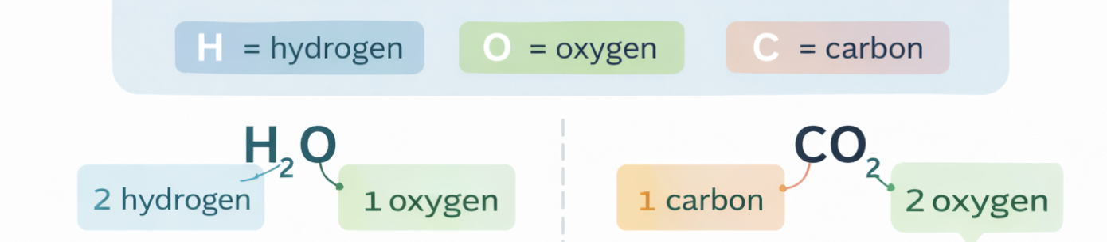
- H₂O contains 2 hydrogen atoms and 1 oxygen atom
- CO₂ contains 1 carbon atom and 2 oxygen atoms
If there is no number, it means there is only one atom of that element.
You can interpret a chemical formula by:
- Naming the elements shown
- Counting how many atoms of each element are present

Questions
- MCQ: What does a chemical formula show?
A. The colour of a compound
B. The elements in a compound and how many there are
C. How hot a reaction is
D. How fast a reaction happens
- Complete the sentence:
A chemical formula uses element __________ to show which elements are present.
- State the number and name of the elements in H₂O.
Element 1: ____________________
Element 2: ____________________
- Complete the sentence:
In CO₂, the number 2 shows that there are __________ atoms of oxygen.
- Describe what it means if there is no number after an element symbol.
If there is no number after an element symbol, it means __________________________.
- A student sees the formula NH₃. Without being told the name of the compound, explain what the formula tells you.
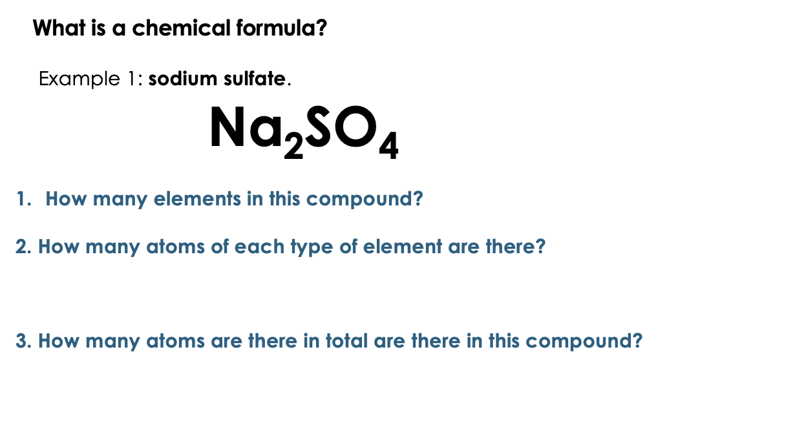
I DO:
WE DO:
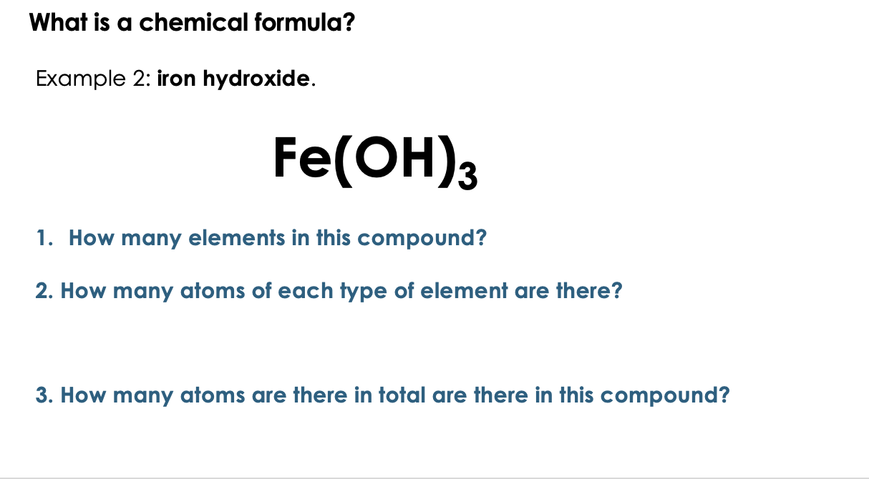

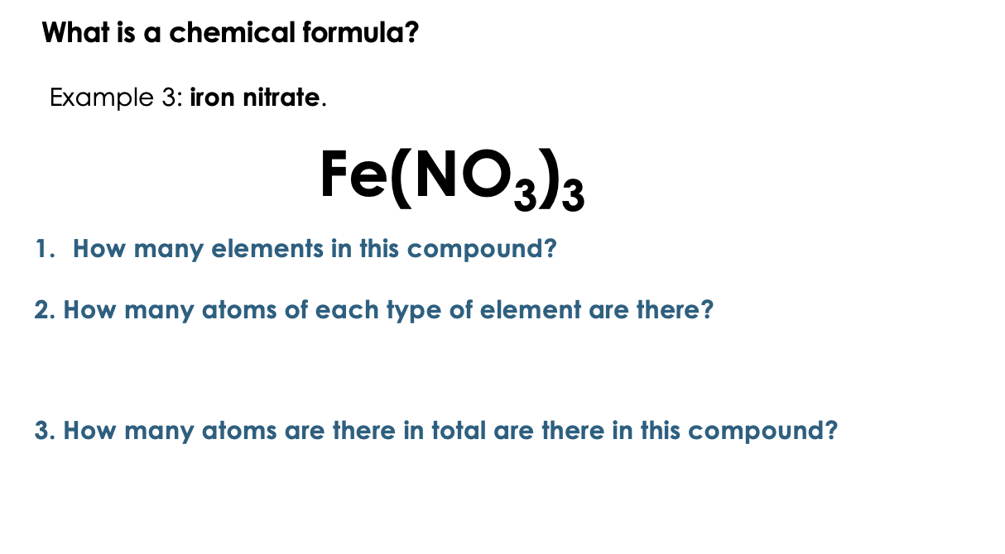
YOU DO:
- Write the correct chemical formula for the following substances:
  - Water
  - Carbon dioxide
  - Oxygen gas
  - Hydrogen gas
  - Hydrochloric acid

- Determine how many atoms of each element are present in the following formulae and name each compound. The first has been done for you:
- NaCl (sodium chloride) contains 1 atom of sodium and 1 atom of chlorine
- MgO ___________________________________ contains __________________________________________________________________________
- SO₂ ___________________________________ contains __________________________________________________________________________
- Na₂S ___________________________________ contains __________________________________________________________________________
- Fe₂O₃ ___________________________________ contains __________________________________________________________________________
- AgNO₃ ___________________________________ contains __________________________________________________________________________

- Determine how many atoms of each element are present in the following compounds.

- Sulfuric acid, H₂SO₄, contains
__________________________________________________________________________
- Barium hydroxide, Ba(OH)₂, contains
__________________________________________________________________________
- Glucose, C₆H₁₂O₆, contains
__________________________________________________________________________
- Ethanol, C₂H₅OH, contains
__________________________________________________________________________
- Nitric acid, HNO₃, contains
__________________________________________________________________________
- Potassium hydroxide, KOH, contains
__________________________________________________________________________

Read Now: Relative Atomic Mass (Ar) Date:____________
Every element has a relative atomic mass, written as Ar.
The Ar of an element is a number that tells us how heavy one atom of that element is.
You can find the Ar of an element on the periodic table.
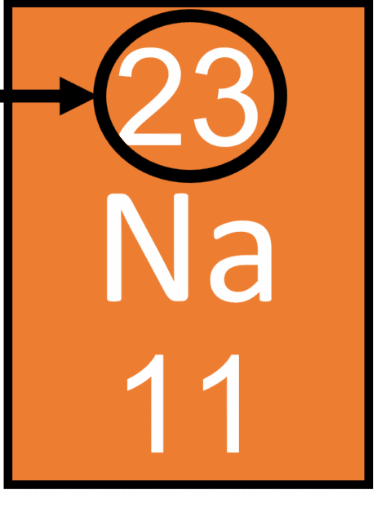
For example:
- Hydrogen has an Ar of 1
- Carbon has an Ar of 12
- Oxygen has an Ar of 16
A compound is made of more than one element.
The relative formula mass of a compound is written as Mr.
The Mr of a compound is found by adding together the Ar values of all the atoms in its formula.
Key ideas
- Ar = relative atomic mass (for one element)
- Mr = relative formula mass (for a compound)
- Ar values come from the periodic table

Questions
- MCQ: What does Ar stand for?
A. Atomic reaction
B. Relative atomic mass
C. Relative amount
D. Atom ratio
- Complete the sentence:
The relative atomic mass of an element is written as __________.
- State where you can find the Ar of an element.
- State the relative atomic mass (Ar) of oxygen.
- Complete the sentence:
The relative formula mass of a compound is written as __________.
- A compound contains carbon and oxygen.
Explain what you would need to know to calculate its Mr.

Answer the following questions.

- Circle the correct word to complete the sentence.

  - Relative atomic mass can also be written as M_{r} / A_{r}
  - Relative formula mass can also be written as M_{r} / A_{r}
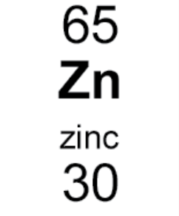
  - The relative atomic mass can be found next to the chemical symbol, on a Periodic Table, and it is always the bigger / smaller / top / bottom number.

  - Circle the relative atomic mass (Ar) on the diagram.

- State the relative atomic mass for the following elements:
  - Nitrogen
  - Bromine
  - Neon
  - Thallium
  - Vanadium
  - Helium
  - Hydrogen
  - Oxygen
  - Carbon
  - Osmium
  - Gold
  - Copper
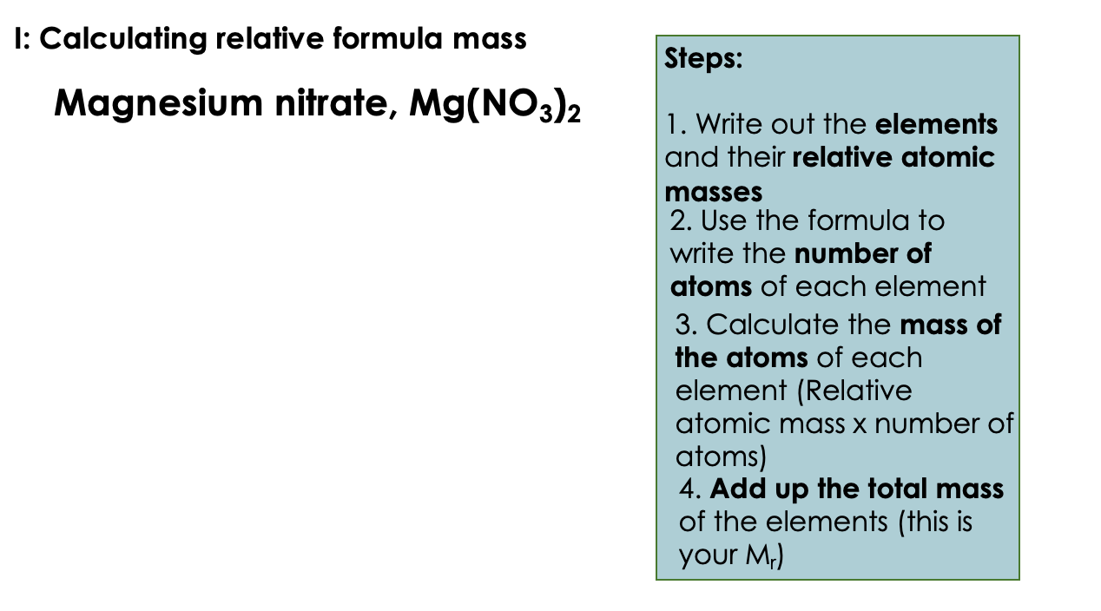

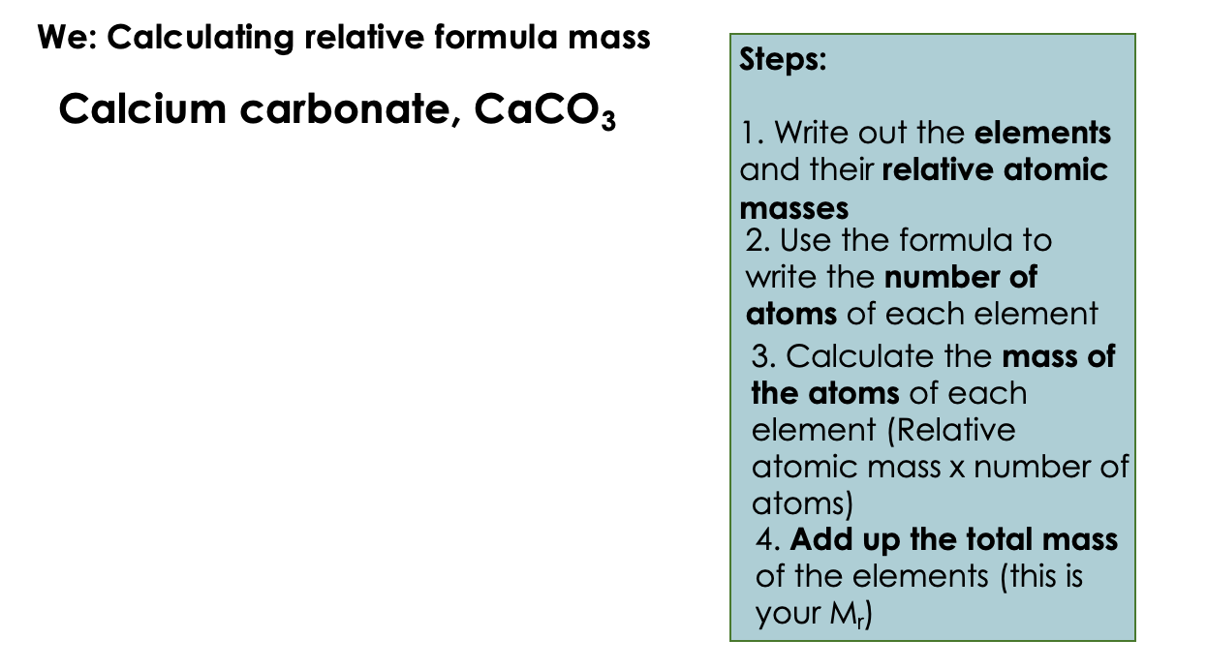

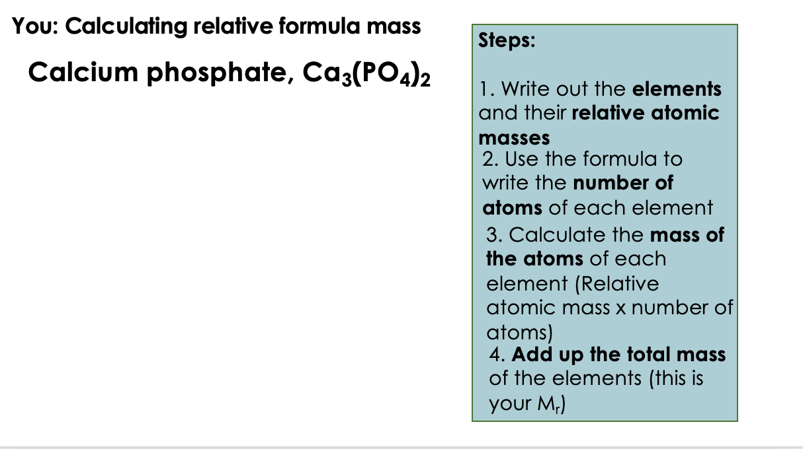

- Calculate the relative formula mass of each of the following compounds.
Show your working.
  - Cl₂
  - H₂
  - H₂O
  - CO₂
  - HCl
  - CuSO₄
  - NaOH
  - Al₂O₃

  - Zn(OH)₂

  - Mg(NO₃)₂

  - Ca(HCO₃)₂

  - (NH₄)₂SO₄

- A metal oxide has the formula MO, where M is the chemical formula for the metal and O is oxygen.
The relative formula mass for this compound is 40.
What is the metal?

